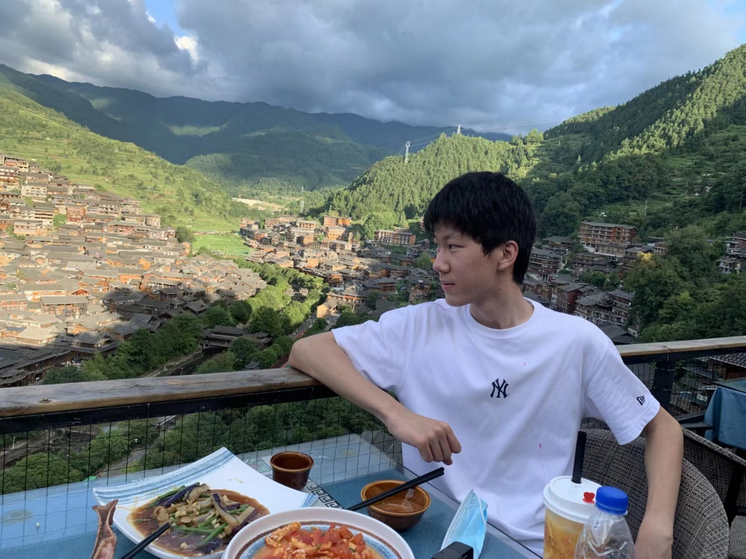

**Self Introduction**

“Born towards the sun, following the light”— I am Li Chengrun, sunshine and confidence are my characteristics. I am a collaborator with a strong team spirit; I am a practitioner with a strong sense of responsibility and collective honor, who works diligently and responsibly, and is hardworking; I am a student worker who is willing to listen to the voices of my classmates, understand the requirements of the college, and provide high-quality services to them.

## Campaign philosophy: Based on reality and serving classmates

Reasons for running for the presidency:

1、I have extensive experience working in SJTU and JI’s associations. As a freshman, I have joined organizations such as the SJTU Singers’ League and the UM-SITU-JI SSTIA. I was responsible for the planning and on-site organization of activities multiple times. Through participating in these activities, I have met a group of like-minded friends and established a strong friendship. It is this kind of friendship that spans colleges and departments that can continuously contribute to organizational construction or innovative activities.

2、I conducted in-depth research on the work of the student union. Communicate with the college's guiding teachers, members of the presidium, and heads of various departments on the main issues and difficulties in student work, and write preliminary improvement plans. If I am elected this time, I hope it can be implemented through the new presidium。

3、I have always had a dream of being someone who can change the world, at least someone who participates in changing the world. The student union is where my dream sets sail. I will put in all my enthusiasm and pass on my dreams to every student through the work of the student union and various organizational activities。

## Section One: Policy Agenda

Core ideas of organizational reform plan：

“Taking departments as dimensions and projects as the center”

The current functional positioning of various departments of the Student Union is feasible, and interdepartmental cooperation can also be directly achieved through communication among ministers. However, there are still the following issues：

(1)There is little cooperation between various departments of the student union. After entering the student union, there are few opportunities to meet classmates from other departments besides my own. You only know the senior and senior students in your own department, you can only know your department’s manager, and no other managers know you either.

(2)The existing scale system is too complete, which may seem like a step-by-step replication, but some activities can be abandoned, while others can be done more。

At present, the barriers between various departments of the student union are still relatively thick. Only through the project operation mode can we unite and motivate project team members to form strong combat effectiveness. So, for different projects, forming two groups of fifteen to twenty people in the student union and consciously cultivating a strong project operation team is the foundation for ensuring the orderly development of project organization and maintaining the overall vitality of the student union's daily operation。

Project-based reform is not about making projects independent of departments, but about implementing a project-based system based on departments. Project management is led by the presidium, and each project must have a core leader. The responsible person defines the work functions of each person involved in the project and closely monitors the implementation of the entire project。

The simple idea is: Consolidate friendships through projects, train a strong team through projects, and form lifelong friendships through projects.

1、A project responsibility system with one department as the main body responsible for project implementation, cooperation from multiple departments, and the overall responsibility of the presidium members。

2、Clarify the supporting role of each department：

1）Strengthen the training of professional skilled personnel in supporting departments, such as the Media Department's photography and camera skills, and the External Relations Department's external sponsorship support, etc。

2）Optimize the responsibilities of the Media Department. The Media Department is responsible for collecting information on various departments and projects, writing press releases, taking photos of other departments, and coordinating with the Integrated Media Center to ensure consistency in information style release。

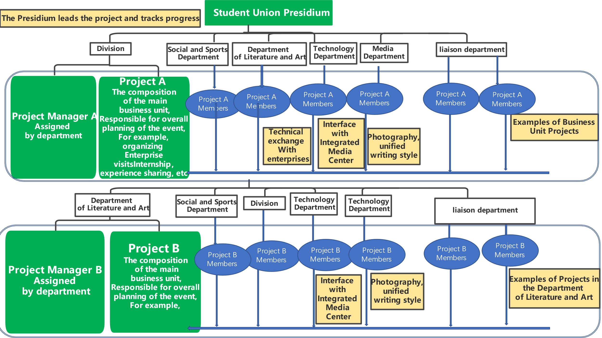

## Section Two: College Culture and Activities

The culture of the school is like a flowing river that needs to be passed on and innovated from generation to generation in perseverance. The work of the Bureau is on the one hand to accumulate, maintain and enhance the cultural work of the school, and on the other hand to judge whether an activity is necessary from the following three perspectives:

1、Whether it can give students a better learning and living environment

2、Whether it can make the students have fun after study

3、Whether it can provide a platform for students to communicate and develop

The specific initiatives are the following activities:

1）Students can have fun outside of their studies: food festivals, ball dances, social gatherings, night markets, etc

2）Activities that parents enjoy: campus visits for parents

3）Provide a platform for communication and development: HC training, school-enterprise visits, internship experience sharing sessions for senior and senior students, EAP psychological consultation activities, and entering Yunnan (a cooperation activity with the school base)

## Section Three: Student rights protection and Feedback

The student union is an organization that represents the voices of students, so it is important to know the pain points of students, collect their concerns, and promptly communicate and implement with relevant departments of the school on behalf of students. The key point is how to collect and confirm the needs of students. Key point 2: How to track and implement problem-solving.

Taking the "online course selection" as an example, we investigated and learned about the needs of students in the service period, determined the current, medium-term and long-term solutions, and released them to students using the official account.

## Section Four: Communication between Student Union and School-level Student Union Organizations

Using "projects" and "activities" as carriers to drive cooperation between school-level and college-level student unions, effectively integrating resources and sharing experiences.

1. Give full play to the extraordinary role of mentors, and the mentors at SJTU are all experienced. The student union needs to communicate and organize activities, first of all, with the support of two teachers in charge of different student union. Communicate with teachers to prepare a plan, propose a relatively reasonable activity plan, and strive for their support in order to provide in-depth communication and corresponding support for the activity from the perspective of the school and the hospital.

2. Secondly, the cadres of the student union should communicate and exchange ideas and suggestions for joint activities or support with other student unions in advance with their corresponding cadres, and listen to their ideas and opinions. If the student union of the other party also has the intention to strengthen communication and cooperation, both parties should promptly agree on the theme, timing, and corresponding venue of the cooperative event, so as to make relatively complete preparations for the event in the end。

3. It is possible for both student union officials to take the lead and privately organize interesting social activities for both student union members. By organizing these activities, both members can understand, communicate, and establish friendships, preparing for the deep cooperation between the two clubs in the future。